Lecture#27 Firebase
Objectives
- Create Firebase Project
- Firebase Authentication

To use Firebase with Flutter,
Step 1: you need to create a Firebase project. Go to the Firebase website and sign in with your Google account. Then click on the "Create Project" button and follow the prompts to create a new Firebase project.

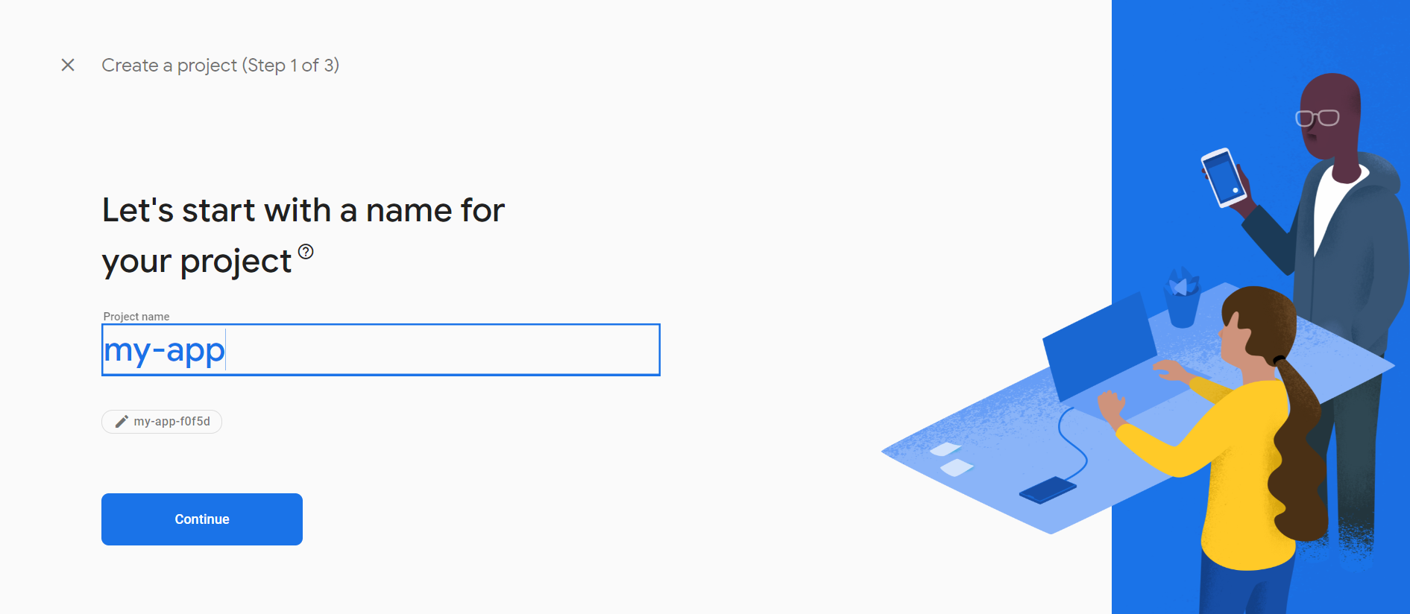

Step 2: Add a Firebase app to your project
Once you have created a Firebase project, you need to add a Firebase app to your project. To do this, go to the Firebase console and click on your project. Then click on the "Add App" button and select "Flutter" as the platform.
Step 3: Register your app with Firebase
After you have added a Firebase app to your project, you need to register your app with Firebase. To do this, follow the instructions in the Firebase console to download the google-services.json file for Android or the GoogleService-Info.plist file for iOS. Place these files in the android/app directory for Android or the ios/Runner directory for iOS.

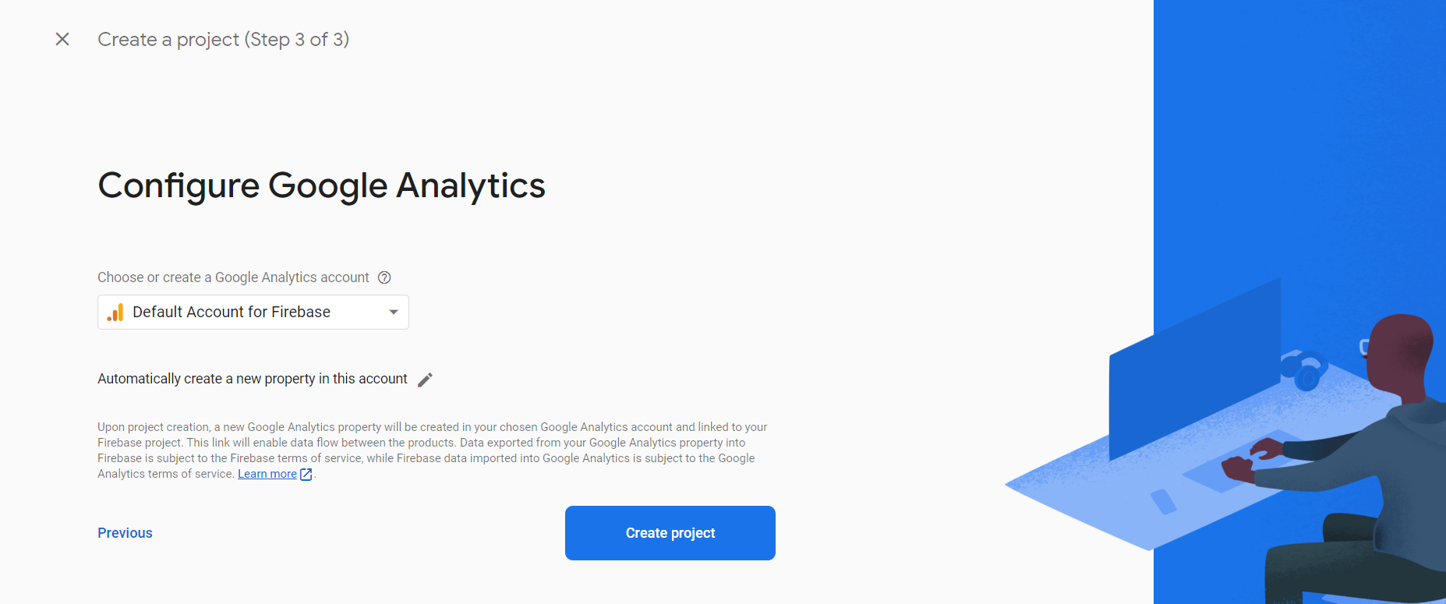

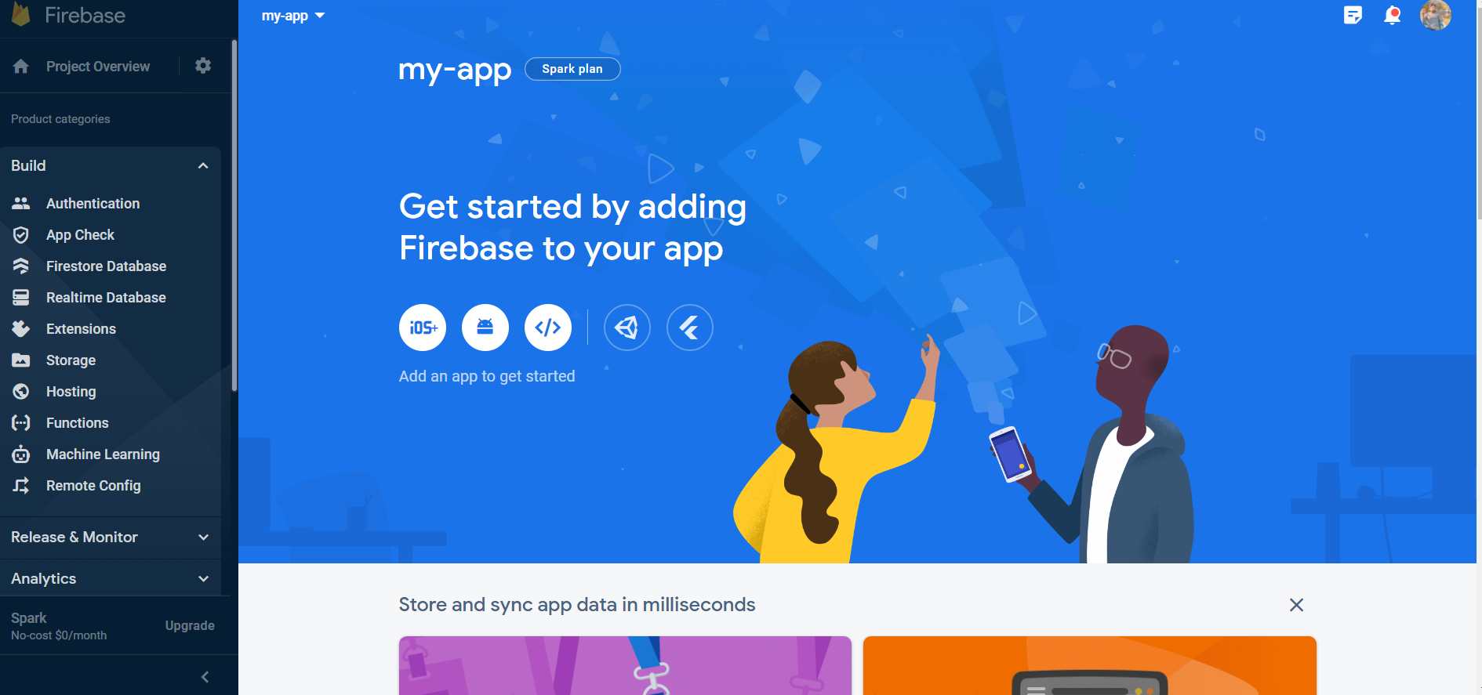

Step 4: Add the necessary dependencies to your project
To use Firebase in your Flutter project, you need to add the necessary dependencies to your pubspec.yaml file. The dependencies you need depend on the Firebase services you want to use. For example, if you want to use the Firebase Authentication service, you need to add the firebase_auth dependency to your project.
Step 5: Initialize Firebase in your Flutter app
After you have added the necessary dependencies, you need to initialize Firebase in your Flutter app. To do this, add the following code to your main.dart file:
import 'package:firebase_core/firebase_core.dart';

void main() async {
WidgetsFlutterBinding.ensureInitialized();
await Firebase.initializeApp();
runApp(MyApp());
}
Firebase Authentication:
- First, you need to add the Firebase Authentication dependency to your Flutter project. To do that, add the following line to your pubspec.yaml file:
dependencies:
firebase_auth: ^3.3.0
- Next, you need to configure Firebase for your Flutter app. You can follow the instructions in the Firebase console to create a new project and add your Flutter app to it.
- Once you have your Firebase project set up, you can initialize Firebase in your Flutter app by adding the following code to your main.dart file:
import 'package:firebase_core/firebase_core.dart';

void main() async {
WidgetsFlutterBinding.ensureInitialized();
await Firebase.initializeApp();
runApp(MyApp());
}
Example code:
import 'package:flutter/material.dart';
import 'package:firebase_core/firebase_core.dart';
import 'package:firebase_auth/firebase_auth.dart';
import 'package:flutter/services.dart';
import 'home_page.dart';
import 'login_page.dart';

void main() async {
WidgetsFlutterBinding.ensureInitialized();
await Firebase.initializeApp();
runApp(MyApp());
}

class MyApp extends StatelessWidget {
@override
Widget build(BuildContext context) {
return MaterialApp(
title: 'Flutter Firebase Auth Demo',
initialRoute: '/',
routes: {
'/': (context) => LoginPage(),
'/signup': (context) => SignupPage(),
'/home': (context) => HomePage(),
},
);
}
}

Login Page:
import 'package:flutter/material.dart';
import 'package:firebase_auth/firebase_auth.dart';
import 'signup_page.dart';
import 'home_page.dart';

class LoginPage extends StatefulWidget {
@override
_LoginPageState createState() => _LoginPageState();
}

class _LoginPageState extends State<LoginPage> {
final _formKey = GlobalKey<FormState>();
final TextEditingController _emailController = TextEditingController();
final TextEditingController _passwordController = TextEditingController();
String _errorMessage = '';

@override
Widget build(BuildContext context) {
return Scaffold(
appBar: AppBar(
title: Text('Login'),
),
body: Padding(
padding: EdgeInsets.all(16),
child: Form(
key: _formKey,
child: Column(
crossAxisAlignment: CrossAxisAlignment.stretch,
children: [
TextFormField(
controller: _emailController,
decoration: InputDecoration(
labelText: 'Email',
),
validator: (value) {
if (value.isEmpty) {
return 'Please enter your email';
}
return null;
},
),
TextFormField(
controller: _passwordController,
decoration: InputDecoration(
labelText: 'Password',
),
obscureText: true,
validator: (value) {
if (value.isEmpty) {
return 'Please enter your password';
}
return null;
},
),
SizedBox(height: 16),
ElevatedButton(
onPressed: _login,
child: Text('Signin'),
),
TextButton(
onPressed: () {
Navigator.pushNamed(context, '/signup');
},
child: Text('Register'),
),
Text(
_errorMessage,
style: TextStyle(
color: Colors.red,
fontSize: 16,
),
),
],
),
),
),
);
}

Login Function:

void _login() async {
if (_formKey.currentState.validate()) {
try {
UserCredential = await FirebaseAuth.instance.signInWithEmailAndPassword(
email: _emailController.text,
password: _passwordController.text,
);
Navigator.pushNamed(context, '/home');
} on FirebaseAuthException catch (e) {
setState(() {
_errorMessage
= e.message;
});
}
Signup Function:

void _signup() async {
if (_formKey.currentState.validate()) {
try {
UserCredential = await FirebaseAuth.instance.createUserWithEmailAndPassword(
email: _emailController.text,
password: _passwordController.text,
);
Navigator.pushNamed(context, '/home');
} on FirebaseAuthException catch (e) {
setState(() {
_errorMessage = e.message;
});
}
}
}
}
}}

Screenshot:
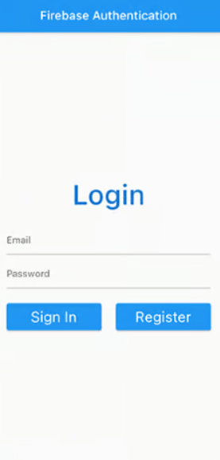

Lecture#28 Firebase Firestore
Objectives
- Todo App Example

TODO app using Flutter and Firebase:
- To Use Firebase in your project create Firebase project and follow steps in previous lecture.
- Set up a new Flutter project and add the Firebase dependencies to your pubspec.yaml file.
dependencies:
flutter:
sdk: flutter
firebase_core: ^1.6.0
cloud_firestore: ^2.5.4
- Initialize Firebase in your main.dart file.
import 'package:flutter/material.dart';
import 'package:firebase_core/firebase_core.dart';
void main() async {
WidgetsFlutterBinding.ensureInitialized();
await Firebase.initializeApp();
runApp(MyApp());
}
Todo model:
class Todo {
String id;
String title;
bool completed;

Todo({required this.id, required this.title, this.completed = false});

factory Todo.fromSnapshot(DocumentSnapshot snapshot) {
return Todo(
id: snapshot.id,
title: snapshot['title'],
completed: snapshot['completed'],
);
}
Map<String, dynamic> toMap() {
return {
'title': title,
'completed': completed,
};
}
}
Add Todo Screen:
class AddTodo extends StatefulWidget {
@override
_AddTodoState createState() => _AddTodoState();
}

class _AddTodoState extends State<AddTodo> {
final _formKey = GlobalKey<FormState>();
final _titleController = TextEditingController();

@override
Widget build(BuildContext context) {
return Scaffold(
appBar: AppBar(
title: Text('Add a new task'),
),
body: Form(
key: _formKey,
child: Column(
children: [
TextFormField(
controller: _titleController,
validator: (value) {
if (value == null || value.isEmpty) {
return 'Please enter a task title';
}
return null;
},
decoration: InputDecoration(
labelText: 'Task title',
),
),
ElevatedButton(
onPressed: () {
if (_formKey.currentState!.validate()) {
// Add the new task to Firebase.
FirebaseFirestore.instance
.collection('todos')
.add(Todo(title: _titleController.text).toMap())
.then((value) {
Navigator.pop(context);
});
}
},
child: Text('Add task'),
),
],
),
),
);
}
}

